손소독제를 포함한 액정 클리너 특허 제10-1880387
http://jmtechkorea.co.kr/sub03/sub0303.asp(특허 내용)
https://brand.naver.com/iamdue/products/5023911388?NaPm=ct%3Dlr8z0hpc%7Cci%3D0e1f1f2ff9714f842804b80e457466e0cbc26215%7Ctr%3Dslsl%7Csn%3D629870%7Chk%3D9ff5bf2cac0c11890a6e9fad1b6b8f4ed84bbbee
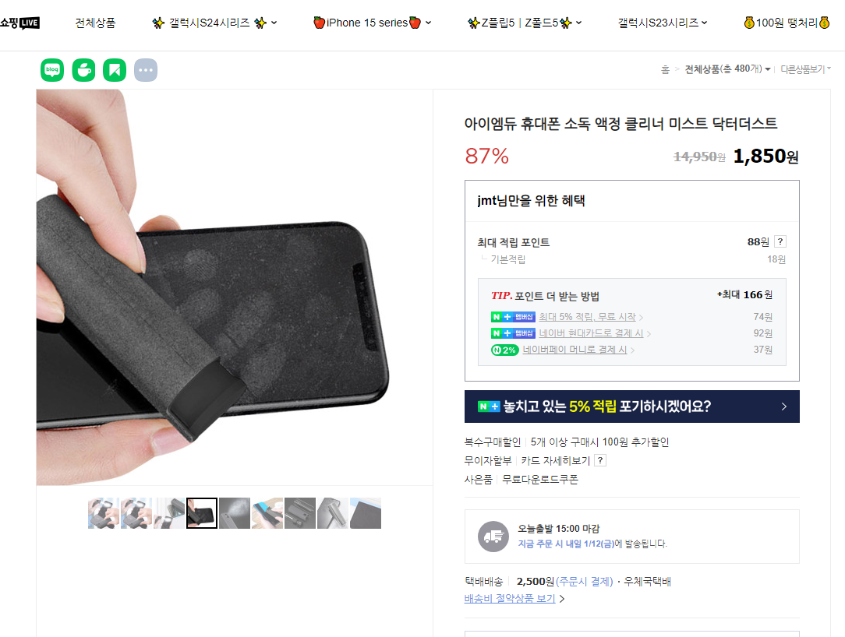
https://smartstore.naver.com/sonofsoil4858/products/8217201595?NaPm=ct%3Dlr8z3u2o%7Cci%3Dbfd739e304b97df4c9dfcae8a9429a111a1b026d%7Ctr%3Dslsl%7Csn%3D1083752%7Chk%3D69e3559778f177ef8d634aba41b857019fc9ff76 (침해 사이트)
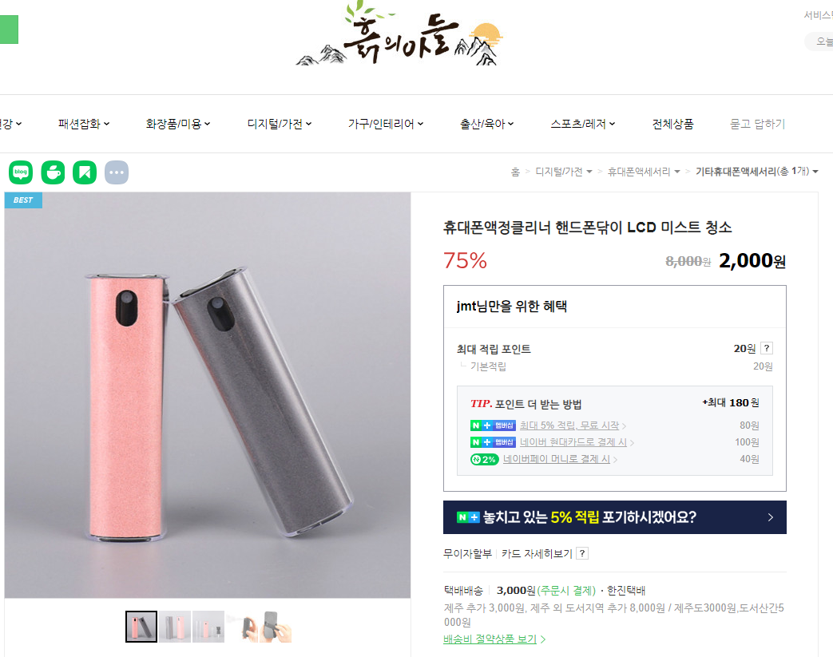

2. 튼살완화를 위한 교체시트형태의 실리콘 장갑 및 실리콘양말
특허 제 10-2108774
http://jmtechkorea.co.kr/sub03/sub0302_3.asp?#order_xy_chk (특허 내용)
https://dailygongam.com/product/detail.html?product_no=1720&utm_source=naver&utm_medium=hot&utm_campaign=&utm_content=bsocks0145&utm_term=bsocks&n_query=bsocks0145&cafe_mkt=nvs_hot01&NaPm=ct%3Dlqx9hg08%7Cci%3Ddba1a37028c9c19836471f0b47584288fc1e64a6%7Ctr%3Dsbsh%7Csn%3D1098398%7Cic%3D%7Chk%3Db819977a764d2121e85b8ae8ccd94658e8dfbef4 (침해 사이트)

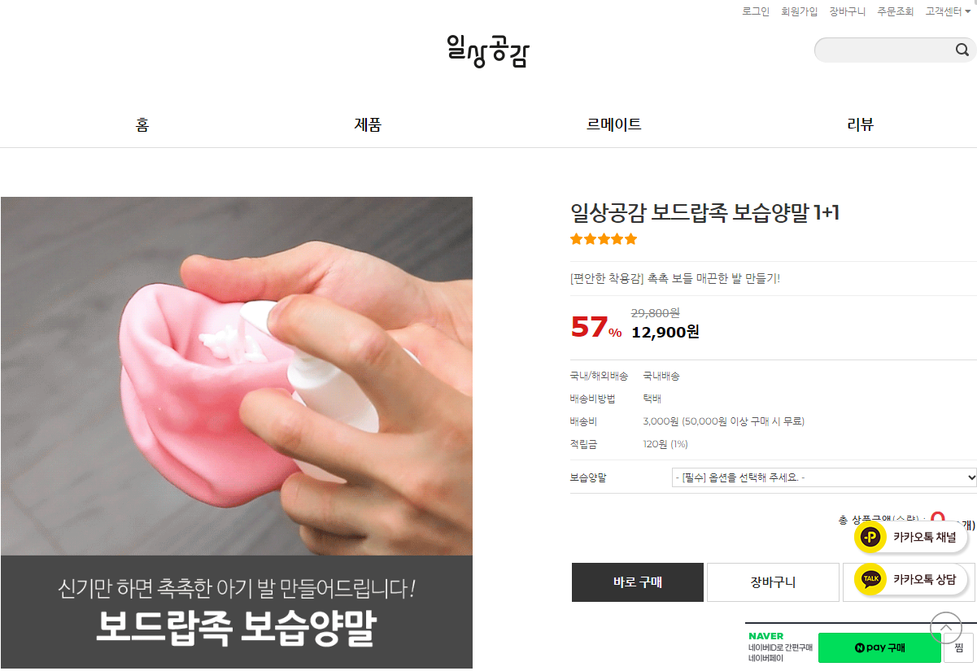

3. 치약 자동공급 플립 캡 특허 제10-1965034
http://jmtechkorea.co.kr/sub03/sub0303_1.asp?#order_xy_chk (치약 플립 캡 특허 내용)
https://www.11st.co.kr/products/6669521903?NaPm=ct%3Dlr8zl7ug%7Cci%3D44ba68cb4926e4e43c4c1f66449d33e80bb0095b%7Ctr%3Dslct%7Csn%3D17703%7Chk%3D56df956ba6747bf3fe11abcc4c45a7026c4df631&utm_term=&utm_campaign=%B3%D7%C0%CC%B9%F6pc_%B0%A1%B0%DD%BA%F1%B1%B3%B1%E2%BA%BB&utm_source=%B3%D7%C0%CC%B9%F6_PC_PCS&utm_medium=%B0%A1%B0%DD%BA%F1%B1%B3 (침해 사이트)

