- 손소독제를 포함한 액정 클리너
특허 제10-1880387
키프리스 http://kportal.kipris.or.kr/kportal/search/total_search.do
(특허 내용)http://jmtechkorea.co.kr/sub03/sub0303.asp
(침해 사이트)
https://brand.naver.com/iamdue/products/5023911388?NaPm=ct%3Dlr8z0hpc%7Cci%3D0e1f1f2ff9714f842804b80e457466e0cbc26215%7Ctr%3Dslsl%7Csn%3D629870%7Chk%3D9ff5bf2cac0c11890a6e9fad1b6b8f4ed84bbbee

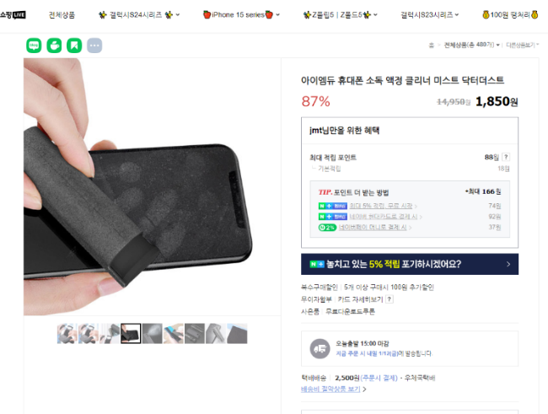
(침해 사이트)
https://smartstore.naver.com/sonofsoil4858/products/8217201595?NaPm=ct%3Dlr8z3u2o%7Cci%3Dbfd739e304b97df4c9dfcae8a9429a111a1b026d%7Ctr%3Dslsl%7Csn%3D1083752%7Chk%3D69e3559778f177ef8d634aba41b857019fc9ff76
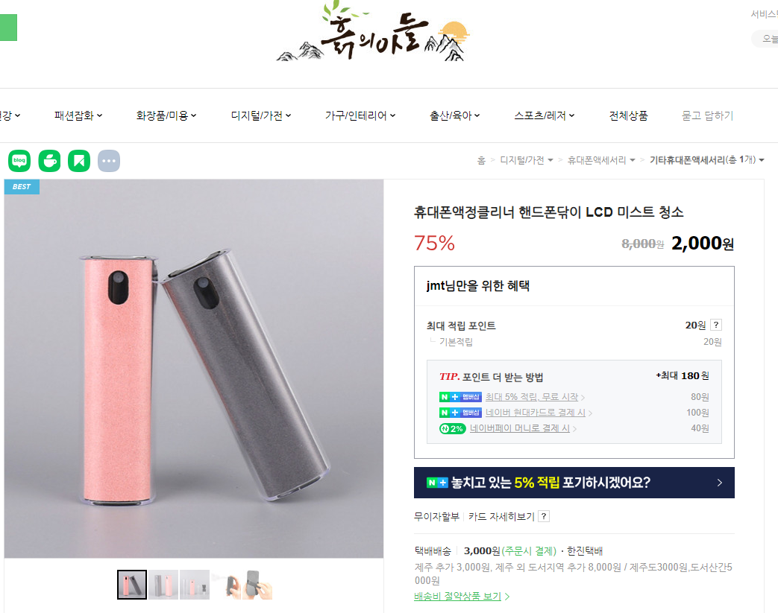

2. 교체식 보습시트를 수용하는 실리콘 양말 및 실리콘 장갑
특허 제 10-2108774
키프리스 http://kportal.kipris.or.kr/kportal/search/total_search.do
(특허 내용)http://jmtechkorea.co.kr/sub03/sub0302_3.asp?#order_xy_chk

(침해 사이트)
https://dailygongam.com/product/detail.html?product_no=1720&utm_source=naver&utm_medium=hot&utm_campaign=&utm_content=bsocks0145&utm_term=bsocks&n_query=bsocks0145&cafe_mkt=nvs_hot01&NaPm=ct%3Dlqx9hg08%7Cci%3Ddba1a37028c9c19836471f0b47584288fc1e64a6%7Ctr%3Dsbsh%7Csn%3D1098398%7Cic%3D%7Chk%3Db819977a764d2121e85b8ae8ccd94658e8dfbef4

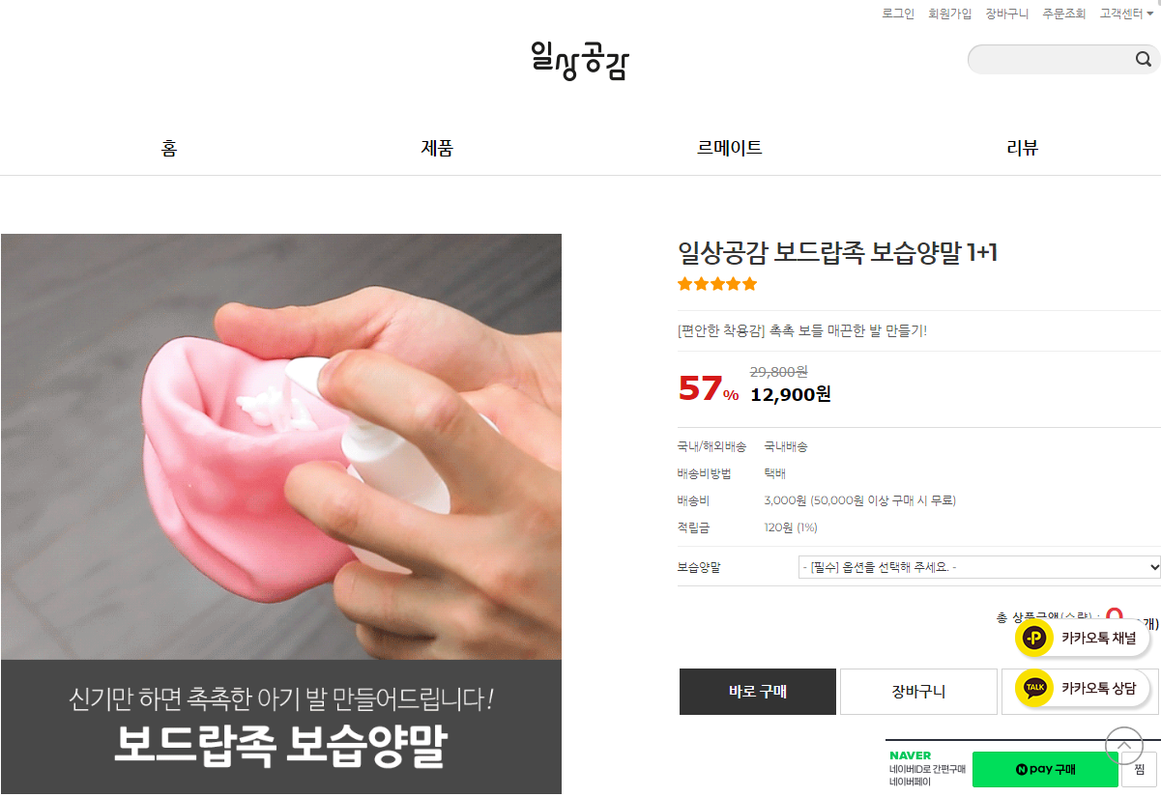

- 치약 자동공급 플립 캡
특허 제10-1965034
키프리스 : http://kportal.kipris.or.kr/kportal/search/total_search.do

(치약 플립 캡 특허 내용) http://jmtechkorea.co.kr/sub03/sub0303_1.asp?#order_xy_chk
(침해 사이트)
https://www.11st.co.kr/products/6669521903?NaPm=ct%3Dlr8zl7ug%7Cci%3D44ba68cb4926e4e43c4c1f66449d33e80bb0095b%7Ctr%3Dslct%7Csn%3D17703%7Chk%3D56df956ba6747bf3fe11abcc4c45a7026c4df631&utm_term=&utm_campaign=%B3%D7%C0%CC%B9%F6pc_%B0%A1%B0%DD%BA%F1%B1%B3%B1%E2%BA%BB&utm_source=%B3%D7%C0%CC%B9%F6_PC_PCS&utm_medium=%B0%A1%B0%DD%BA%F1%B1%B3

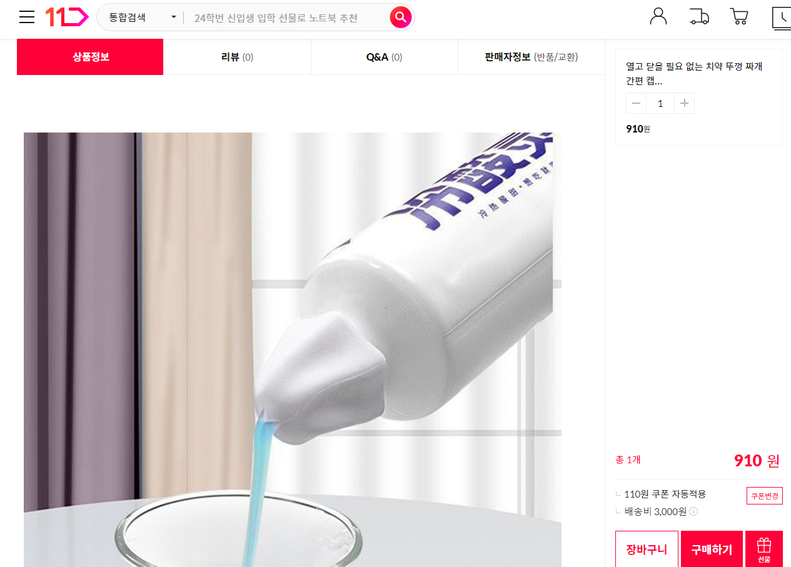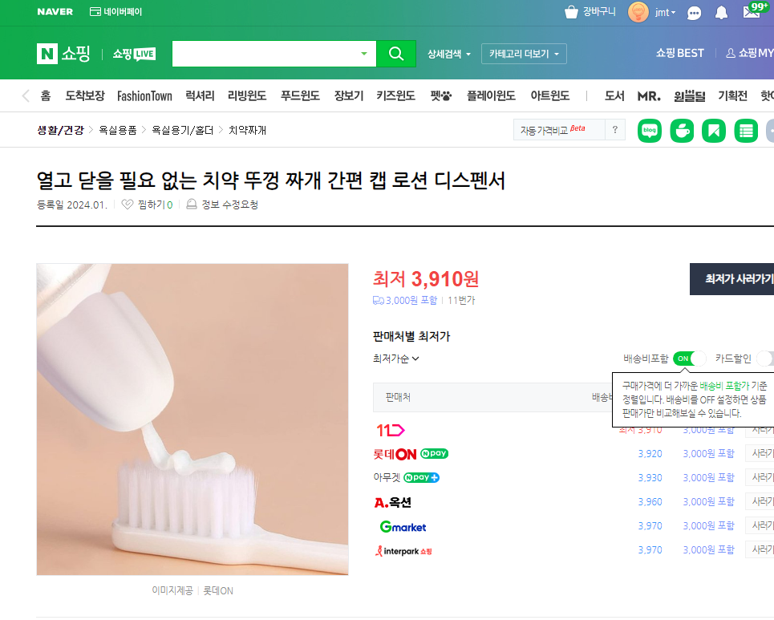

4.현악기 연습용 손가락보호 반지
특허 제 10-19977569
키프리스 http://kportal.kipris.or.kr/kportal/search/total_search.do
특허내용 http://jmtechkorea.co.kr/sub03/sub0304_2.asp?#order_xy_chk

침해사이트
https://search.shopping.naver.com/catalog/33402462964?query=%ED%98%84%EC%95%85%EA%B8%B0%20%EC%97%B0%EC%8A%B5%EC%9A%A9%20%EC%86%90%EA%B0%80%EB%9D%BD%EB%B3%B4%ED%98%B8%20&NaPm=ct%3Dlr998w1s%7Cci%3D29c2b26a691bcf8186b89e053fa3e242d70b33bd%7Ctr%3Dslsl%7Csn%3D95694%7Chk%3Da859b61b3d59ea888cdcb5df890b337fd052dfd8
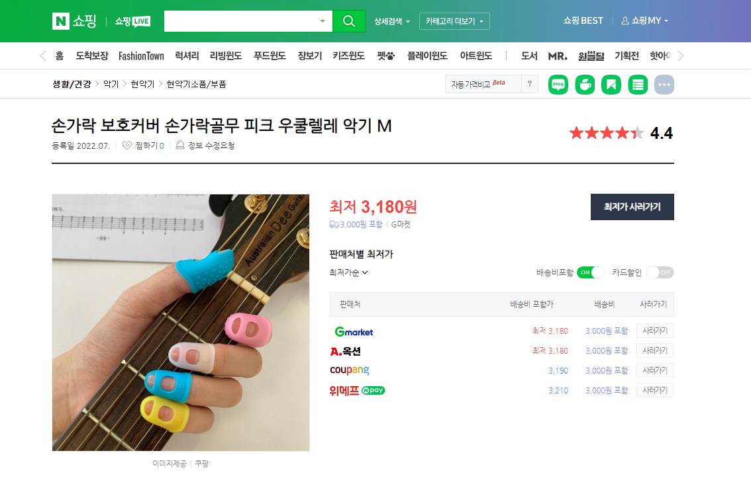

5. 똑딱단추를 이용한 다용도 묶음장치
특허 제 10-1922979
키프리스 http://kportal.kipris.or.kr/kportal/search/total_search.do
특허내용 http://jmtechkorea.co.kr/sub03/sub0306_3.asp?#order_xy_chk

침해사이트
https://www.tmon.co.kr/deal/24913416594?NaPm=ct%253Dlr99pzsg%257Cci%253D4abe3ba5b064723aeb5be90d51db158e38167233%257Ctr%253Dslsl%257Csn%253D221844%257Chk%253De52f3dae25e46be614b3c8dafe5a96637e7e78ce&tmonProcess=entryPath&coupon_srl=3339242&utm_source=naver&utm_medium=affiliate&utm_term=72093_1008&utm_content=&utm_campaign=META_%EB%84%A4%EC%9D%B4%EB%B2%84%EC%A7%80%EC%8B%9D%EC%87%BC%ED%95%91
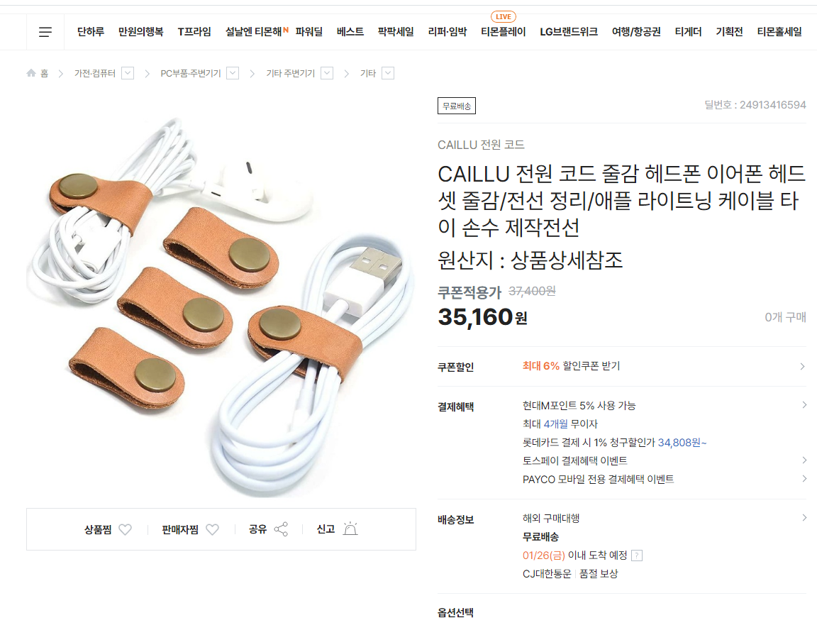

6. 충격완화기능의 대형 악기 이동장치
특허 제 10-2116609
키프리스 http://kportal.kipris.or.kr/kportal/search/total_search.do
특허소개 http://jmtechkorea.co.kr/sub03/sub0304.asp?#order_xy_chk
침해사이트
http://itempage3.auction.co.kr/DetailView.aspx?ItemNo=D849478089&frm3=V2
